API PART II

Materials Needed:
- A computer with Flutter installed.
- A code editor (like VS Code or Android Studio).
- The provider package installed in your Flutter project.

Instructions:
Use the previous code to before starting. Replicate the code snippet.
Follow and implement the enhancement instructions.

Steps:
In your surname_advmobprogAY2627 (root) under it surname_advmobprog make the following
Clean the pubspec.yaml (sample only)
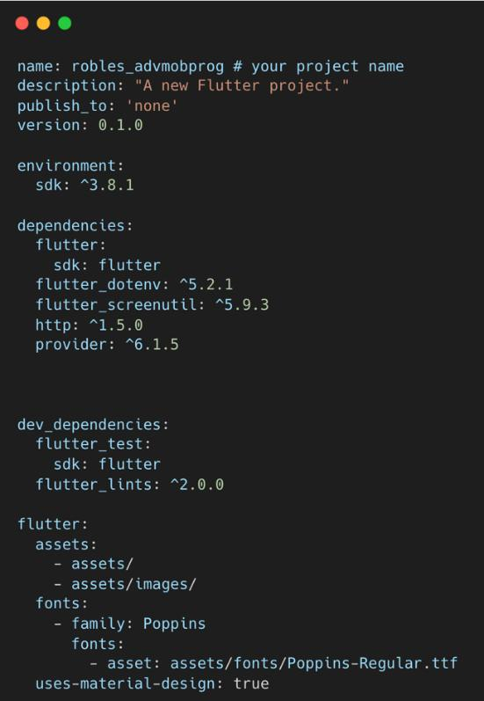

Create these folders and files under the project folder with this design pattern.
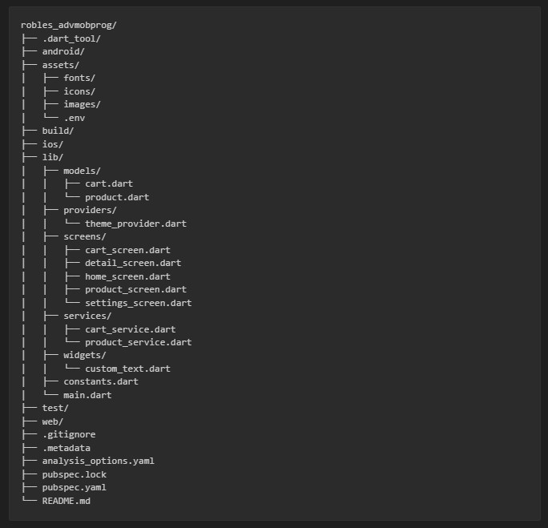

Source Code


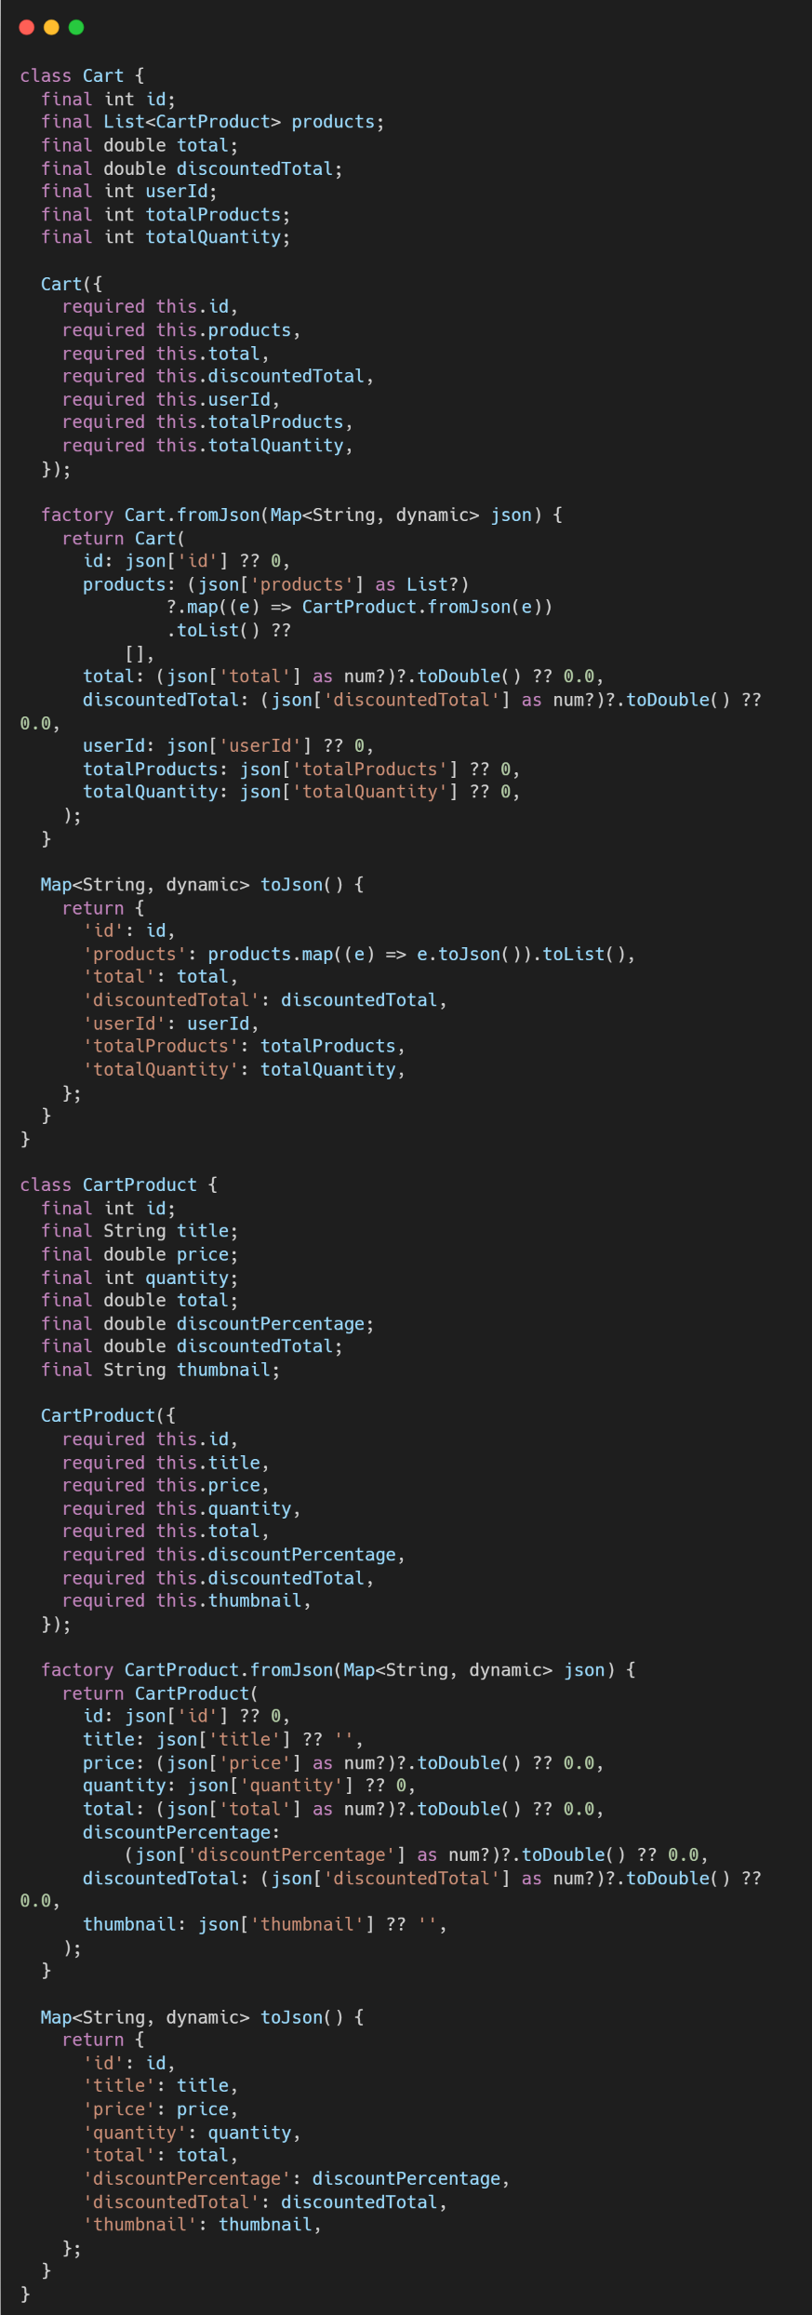
model/cart.dart


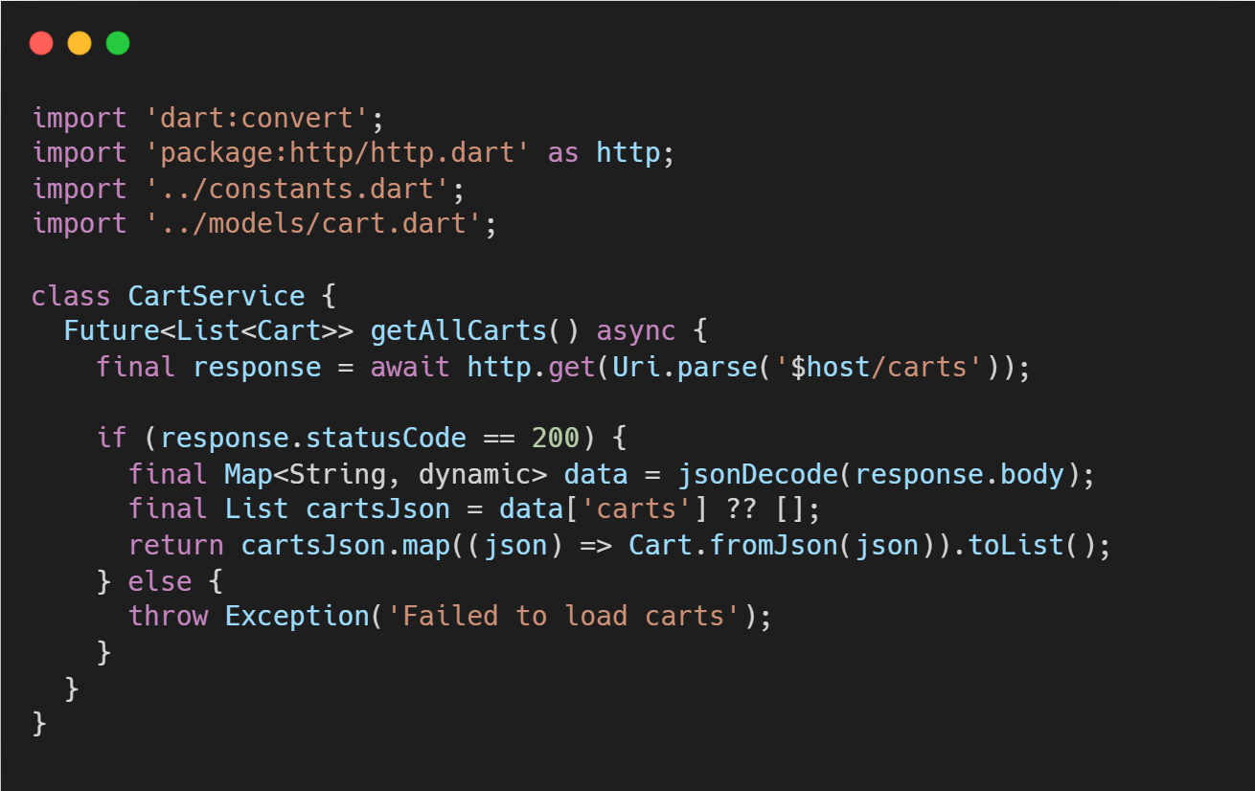
service/cart_service.dart

Enhancements:
Comment in the source code each enhancement you’ve been implemented.

Enhancement 1: Make a cart_screen in order to render the new API endpoint. The items on the cart_screen must be clickable going to the detail_screen for the utilization of the screen widget.
Enhancement 2: Make the chat bottom navigation as FloatingActionButton. When in the cart_screen the FloatingActionButton must be hidden.
Enhancement 3: Read the Cart documentation https://dummyjson.com/docs/carts and check how to integrate cart by user id. To render only one user cart. Also try to use add to cart by passing the values of the product => cart https://dummyjson.com/carts/add


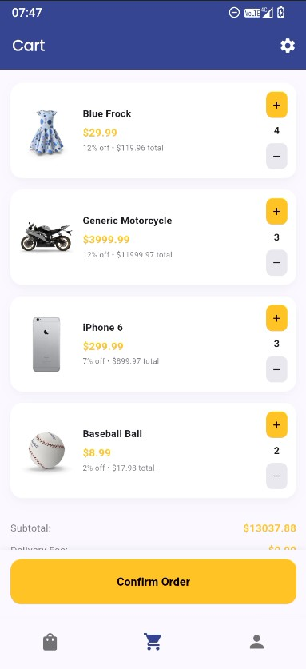
Sample Output:

Laboratory Discussion: Discuss how the cart model, services and screen interact with each other to render the API endpoint going to the same detail_screen.dart. Discuss the updated design pattern in this activity. Also discuss how to use getbyId at Cart endpoint.

Git Instruction:
Update first the README.md file adding the discussion part for example:
Lab Activity 3: discussion

after the hands-on and updating the README.md (must be on root folder surname-advmobprogAY2c27)

- git checkout -b lab_act3
- git add .
- git commit -m “lab_act3”
- git push origin lab_act3

Activity Rubrics

Criteria | Excellent (4 pts) | Good (3 pts) | Fair (2 pts) | Poor (1 pt) | Points
Code | Code runs flawlessly, | Code mostly | Noticeable errors | Code does not run
Implementation | includes all required  features | correct, minor  errors, or missing | or missing two or  more features. | or is significantly  incomplete.
 | (placeholders, | one minor feature.
 | avatars, widgets for
 | like/comment).
Design | UI closely resembles | Layout mostly | Layout deviates | Layout is
Consistency | intended layout,  proper spacing, | accurate, minor  spacing or | significantly from  the intended | unrecognizable or  does not follow
 | alignment, and | alignment issues. | design or appears | the instructions.
 | styling. |  | incomplete.
Use of Widgets and | Properly implements | Most widgets are | Widgets are | Widgets are not
Enhancements | widgets for  placeholders, avatars, | correctly  implemented, with | inconsistently  used or missing | used, or  enhancements
 | and like/comment | minor issues or | two or more | are not
 | buttons. | missing one | enhancements. | implemented.
 |  | enhancement.
Code Organization | Code is well- | Code is mostly | Code is poorly | Code is
and Readability | structured, follows  best practices, and | organized and  readable, minor | organized or does  not follow the | disorganized and  difficult to
 | adheres to the | deviations from | specified | understand.
 | specified file | the required | structure.
 | organization. | structure.
Back-End | Back-end integration | Back-end | Back-end | Back-end
Integration | works flawlessly with  efficient API calls, | integration is  mostly correct | integration has  noticeable flaws or | integration has  major issues;
 | secure data handling, | with only minor | inefficiencies; | frequent failures,
 | and real-time | API, data, or | multiple API calls | poor response
 | updates; no errors or | response handling | fail or data | handling, or
 | downtime. | issues. | handling is | insecure
 |  |  | inconsistent. | practices.
 | Other Comments/ Observations: |  |  | Total Score
 |  |  |  | Rating: (Total Score/20) * 100

